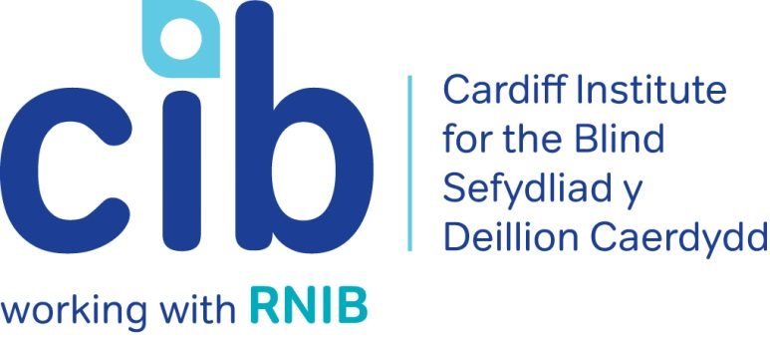

Job Description and Personal Specification - Community Support Coordinator

General Information
Job Title: Community Support Coordinator

Location: Office base is Cardiff but the role is mainly an outreach one covering Cardiff & the Vale of Glamorgan. The post may require working in other South East Wales locations.

Salary: £16,000 - £23,600 pro rata
Hours: 28 hours per week

Responsible for: Volunteers in geographical area covered by post

Reports to: Locality Manager

Additional: The successful candidate will be expected to undergo a DBS check

Background
Cardiff Institute for the Blind is part of the RNIB Group of charities and works closely with RNIB Cymru to make every day better for blind and partially sighted people. The charity was established in 1865 and provides direct services to people across South Wales.

Job Purpose

To work directly and through volunteers (on an individual and group basis) to support blind and partially sighted people maintain or improve their physical and emotional wellbeing and to enjoy independent and fulfilled lives.

This primarily includes:

1. Supporting blind and partially sighted people in accessing information, advice and services.

2. Developing, providing and co-ordinating services to support to blind & partially sighted people on an individual and group basis.

3. Providing support to the Locality Manager in the development and delivery of services and support for blind and partially sighted people.

Equal Opportunities Statement

CIB is committed to being an equal opportunities organisation. It is committed to promoting equal opportunities and preventing discrimination. This policy applies to both its service delivery and to its own employment practices. You will be willing and able to demonstrate commitment to CIB's Equal Opportunities Policy.

Key Functions/Main Tasks

1. Promote, facilitate and develop the concept of independence, confidence and self-advocacy for people with sight loss.

2. Arrange and carry out home visits, reviewing people's circumstances and providing advice and/or referrals as appropriate.

3. Receive and process referrals from statutory and voluntary agencies as well as self referrals.

4. Support blind and partially sighted people to access appropriate support and advice, including sensory services and RNIB services such as education, employment, welfare rights and digital inclusion.
5. Deliver direct individual and group support to blind and partially-sighted people, assisting individuals and groups to determine their own needs using a person-centred approach.

6. Engage individuals and organisations in the community to encourage people to take-up services and/or support us through volunteering, fundraising and awareness raising.

7. Demonstrate a wide range of specialist products to individuals and groups, providing advice and support on purchasing as appropriate.

8. Advise local people who are blind or partially sighted and/or their family and friends about how to raise local issues affecting them.

9. Assist people with sight loss in the identification of gaps in local service provision and facilitate this information being made available to the Locality Manager.

10. Support groups to apply for funding and to access other services.

11. Support the development of relationships with key local partners and stakeholders. Cardiff Institute for the Blind has a Service Level Agreement with Cardiff Council and the Vale of Glamorgan Council.

12. Support the coordination and support of volunteers in the delivery of services. Participate in supervision, training and development of volunteers as required.

13. Collate data on service-users and services delivered.

14. Keep accurate and up-to-date records and monitor effectiveness of outcomes with all clients.

15. Ensure and maintain confidentiality of all records.

16. Undertake any other duties as appropriate.

Person Specification

1. Knowledge

1.1. Knowledge of issues and difficulties experienced by people with disabilities.

1.2. Knowledge of working/liaising with statutory and voluntary agencies.

Desirable

1.3. An understanding of visual impairment and its impact upon those living with sight loss.

1.4. An understanding of the Equalities Act.

1.5. An ability to communicate in Welsh.

2. Skills

2.1. Ability to communicate effectively, both verbally and in writing, adapting style to suit the audience, in order to network with external agencies and promote services.

2.2. Ability to take direction and manage time effectively.

2.3. Ability to take responsibility for own actions, make decisions without referring to others and use initiative.

2.4. Ability to quickly learn and use new information, such as when demonstrating technical products and explaining services such as RNIB Welfare Rights.

2.5. Ability to provide line manager with clear, concise written updates and oral presentations as and when required.

2.6. Ability to deal appropriately with sensitive issues and confidential information.

2.7. Evidence of a flexible approach to meet the developmental needs of the post.

2.8. Ability to be receptive to and seek new ideas and methods of working.
3. Special Conditions

3.1. Appointment is subject to a DBS check.

3.2. Willingness to travel throughout the UK, including occasional overnight stays.

